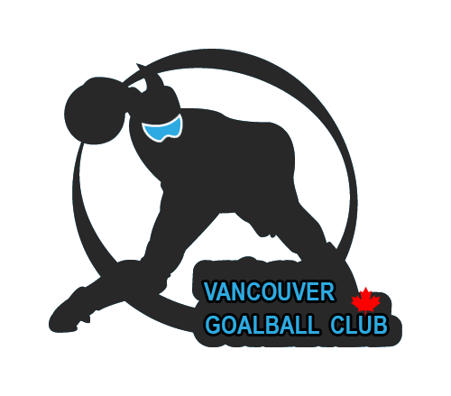

2020 Vancouver Goalball

Grand Slam

– First Entry Form –

DATES: March 13 – 15, 2020
LOCATION: Surrey, BC @ Guildford Recreation Centre
EVENT ORGANIZER: Vancouver Goalball Club

1. Team Name:

2. Province/Country:

3. Number of players:

4. Number of staff members:

5. Your contact person:

Name:

Phone:

Email:

EVENT CONTACT PERSON:
Ahmad Zeividavi
Phone: +1-604-779-3021
Email: vancouvergoalballclub@yahoo.ca

Deadline for the first entry form is January 31, 2020.

