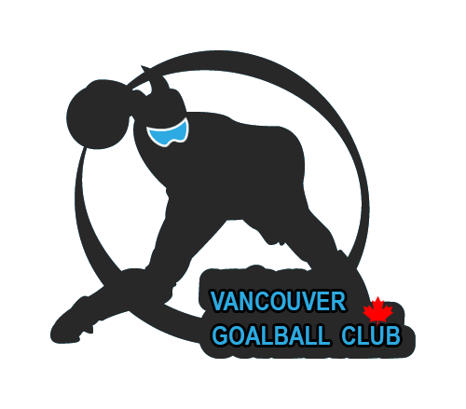

2017 International Vancouver Goalball Grand

Slam First Entry Form

DATES: March 3 – 5, 2017
LOCATION: Langley, British Columbia, Canada
EVENT ORGANIZER: Vancouver Goalball Club

1. Team Name:___________________________________________________

2. Country:_______________________________________________________

3. Number of players:_____________________________________________

4. Number of staff members:_______________________________________

5. Your contact person:

Name:_________________________________

Phone:_________________________________

Email:__________________________________

EVENT CONTACT PERSON:
Ahmad Zeividavi
Phone: +1-604-779-3021
Email: vancouvergoalballclub@yahoo.ca

Deadline for the first entry form is January 15, 2017.

